Project Design Phase-II

Data Flow Diagram & User Stories

|  |  |
| --- | --- |
| Date | 14 October 2022 |
| Team ID | PNT2022TMID34253 |
| Project Name | Project - Skill / Job Recommender Application |
| Maximum Marks | 4 Marks |

# Data Flow Diagrams:

A Data Flow Diagram (DFD) is a traditional visual representation of the information flows within a system. A neat and clear DFD can depict the right amount of the system requirement graphically. It shows how data enters and leaves the system, what changes the information, and where data is stored.

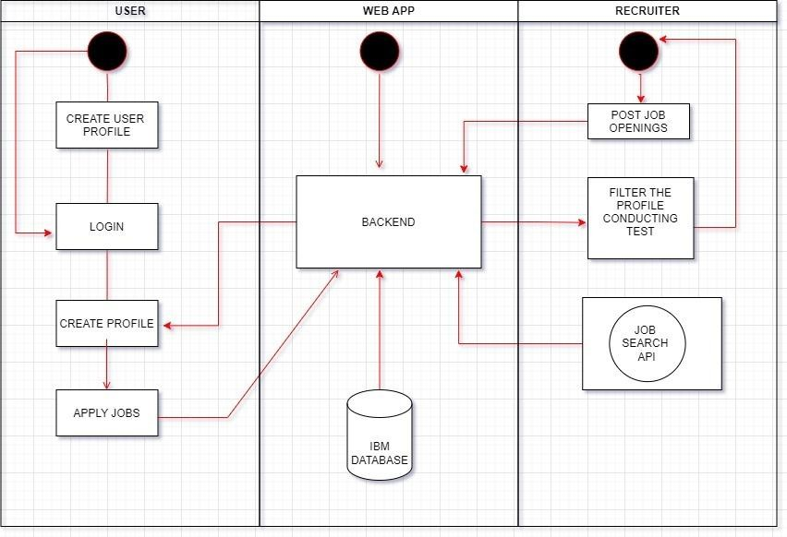

# User Stories

Use the below template to list all the user stories for the product.

|  |  |  |  |  |  |  |
| --- | --- | --- | --- | --- | --- | --- |
| **User Type** | **Functional Requirement**  **(Epic)** | **User Story Number** | **User Story / Task** | **Acceptance criteria** | **Priority** | **Release** |
| Customer (Web user) | Registration | USN-1 | As a user, I can register for the application by entering my email, and password, and confirming my password. | I can access my account/dashboard | High | Sprint-1 |
|  |  | USN-2 | As a user, I will receive a confirmation email  once I have registered for the application | I can receive a  confirmation email & click confirm | High | Sprint-2 |
|  |  | USN-3 | As a user, I can register for the application  through Facebook | I can register & access the  dashboard with Facebook Login | Medium | Sprint-3 |
|  |  | USN-4 | As a user, I can register for the application  through Gmail | I can register & access the  dashboard with Gmail Login | Medium | Sprint-3 |
|  | Login | USN-5 | As a user, I can log into the application by  entering email & password | I can access the  dashboard | High | Sprint-1 |
|  | Dashboard | USN-6 | Genera Dashboard for job seekers through this dashboard see the jobs applied and the  status of jobs. | Job seekers: I can see the job status | High | Sprint-1 |
|  |  | USN-7 | The UI which more flexible in large and small devices | Access through all devices | High | Sprint-1 |
|  | Search or Filter | USN-8 | The filter section gives more flexibility to a  searching job and time saver. | As a user, I can search for  the desired company's | Medium | Sprint-2 |
|  | Apply | USN-9 | As a user, I can apply for a company and  submit the application | Able to ably jobs | High | Sprint-2 |
| Customer Care Executive | Bot or Virtual Assistant | USN-10 | As an executive to provide a quality-based service chatbot is important for assisting if any assistance is needed for the user | Able to handle user queries | Medium | Sprint-3 |
| Administrator | Admin Dashboard | USN-11 | Admin can make change the job posts and able to update the job is active or inactive. | Able to update, delete and change the status of the  job posts. | High | Sprint-1 |
|  |  |  |  |  |  |  |
|  |  |  |  |  |  |  |

|  |  |  |  |  |  |  |
| --- | --- | --- | --- | --- | --- | --- |
| **User Type** | **Functional Requirement**  **(Epic)** | **User Story Number** | **User Story / Task** | **Acceptance criteria** | **Priority** | **Release** |
|  |  |  |  |  |  |  |